**MANCHTANTRA**

**Santosh Deemed To Be University Theatre Club**

**Inception and Vision:**

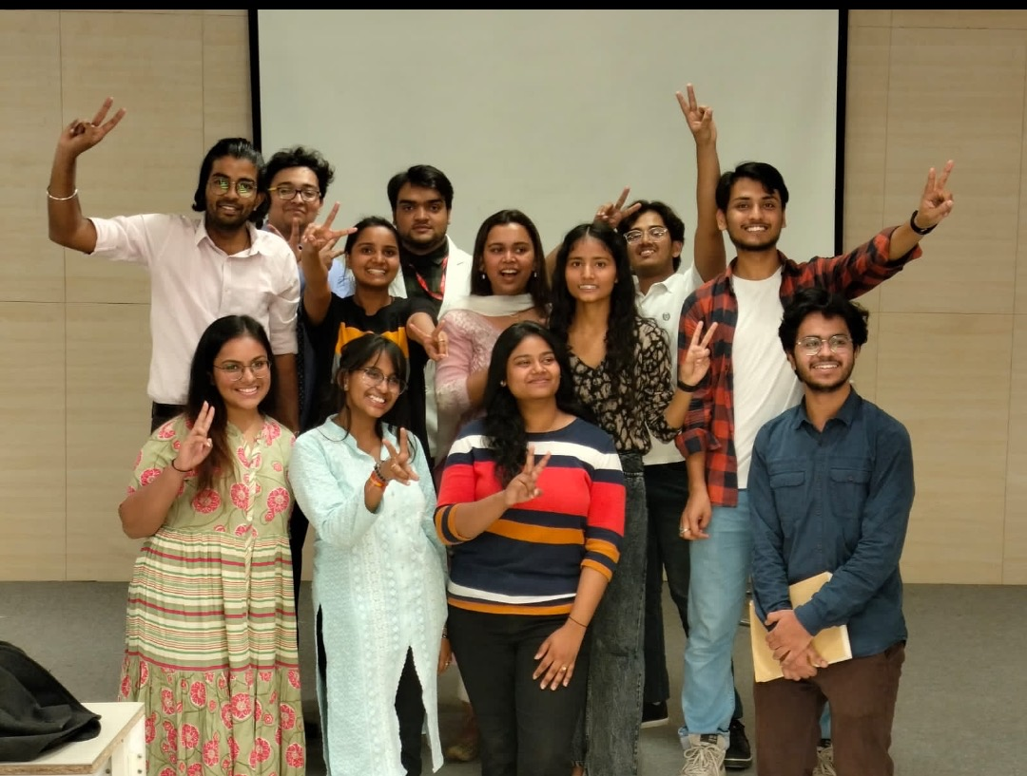Initiated by the student council and endorsed by Dean Student Welfare, Dr. Rajiv Ahluwalia, MANCHTANTRA, the Theatre Club of Santosh Deemed To Be University, came to life. A Google form was crafted to attract entries from enthusiastic students keen on exploring the realms of drama, dance, and music. This fusion club aspires to nurture talents in dramatics, scriptwriting, prop-making, and more.

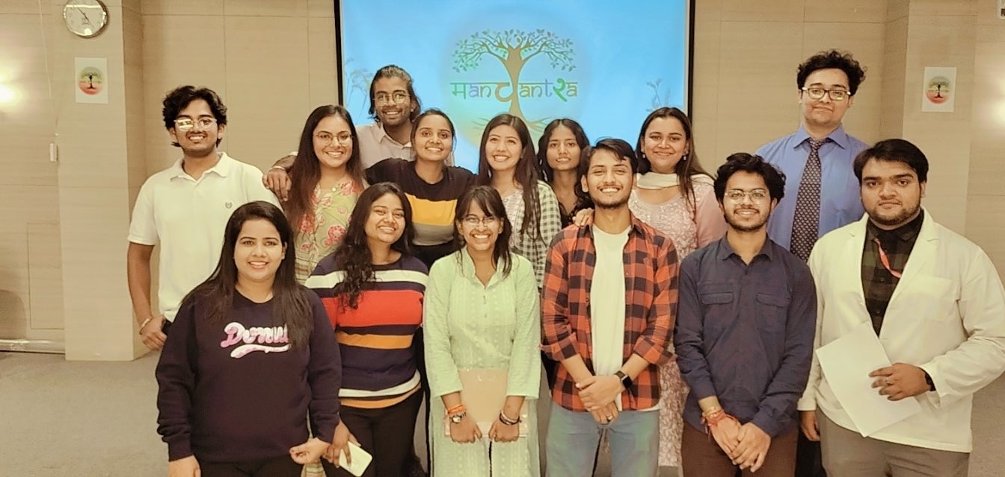

**Mission and Objectives:**

MANCHTANTRA's mission is to boost participation in inter and intracollegiate events, fostering extra-curricular activities and contributing to personality development. The club envisions becoming a hub for creative exploration and skill enhancement within the university.

**Inauguration Ceremony - Children's Day, 14th November 2022**:

In the grandeur of Maharaja Hall, an inauguration ceremony unfolded on Children's Day, with esteemed dignitaries gracing the occasion:

- Dean Student Welfare, Dr. Rajiv Ahluwalia

- Dean Dental, Dr. Akshay Bhargava

- Director IQAC, Dr. Dakshina Bisht

- Dean Academics, Dr. Shalabh Gupta

- HOD Conservative Dentistry and Endodontics, Dr. Sumita Giri Nishad

- Faculty Orthodontics, Dr. Mayank Gupta

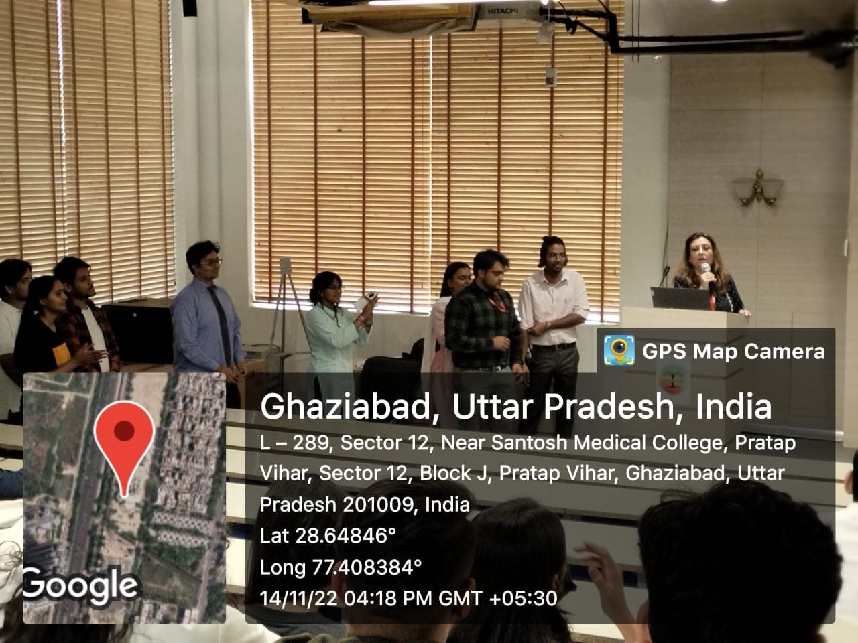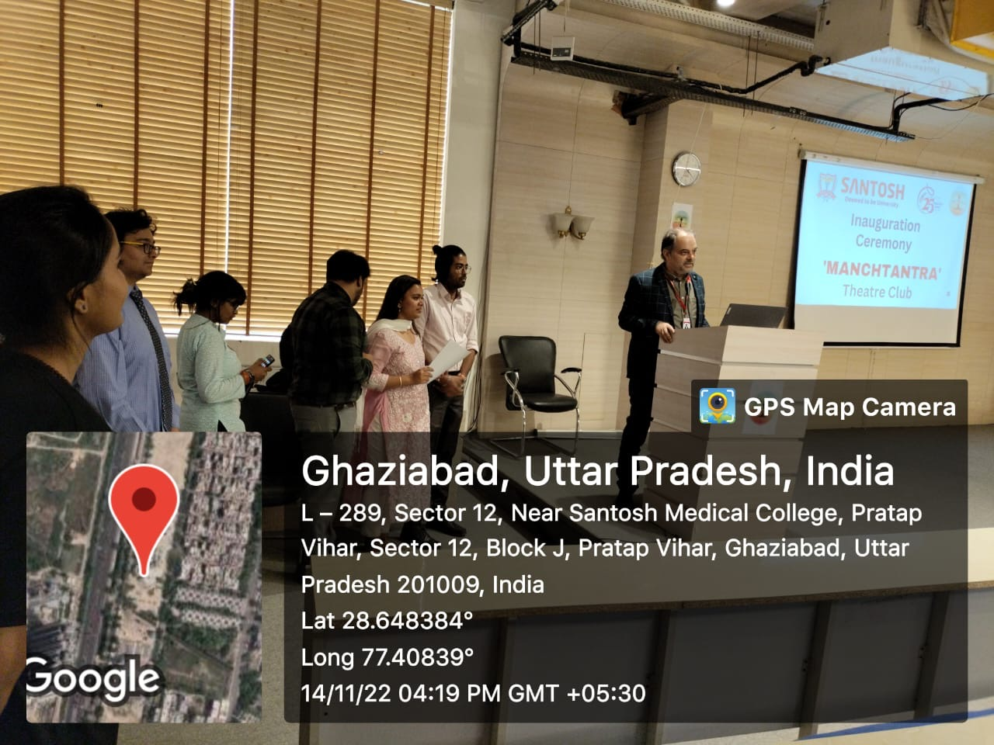The event commenced with warm welcomes and enlightening words from the patrons. A group photograph capturing the essence of this new venture was taken.

**Performance Showcase**:

Embracing the spirit of Children's Day, MANCHTANTRA's inaugural performance presented a captivating symphony of drama, music, and dance. Participants and the audience alike were swept away by the enthusiasm and creativity displayed.

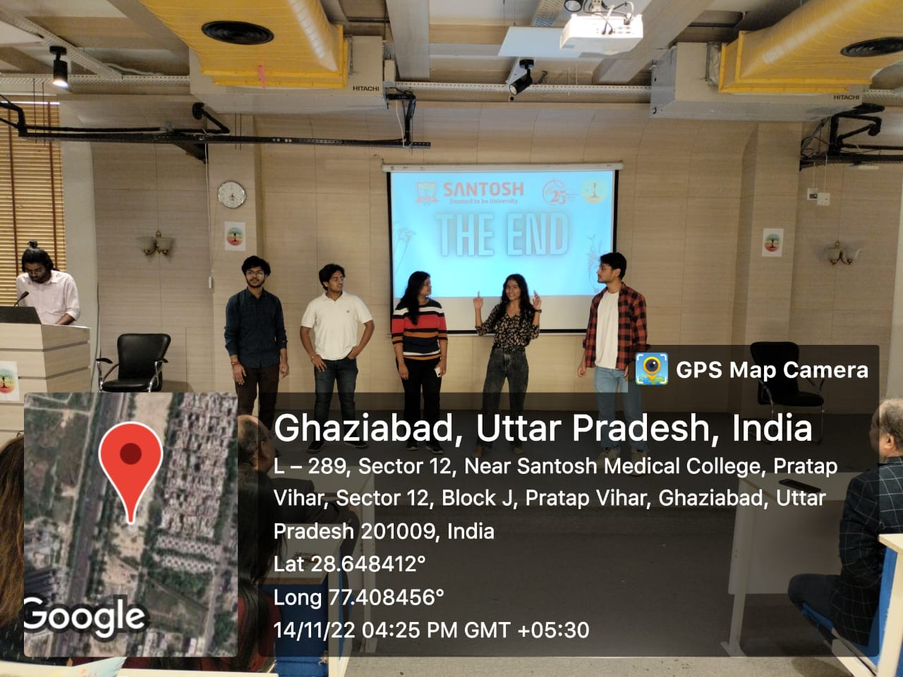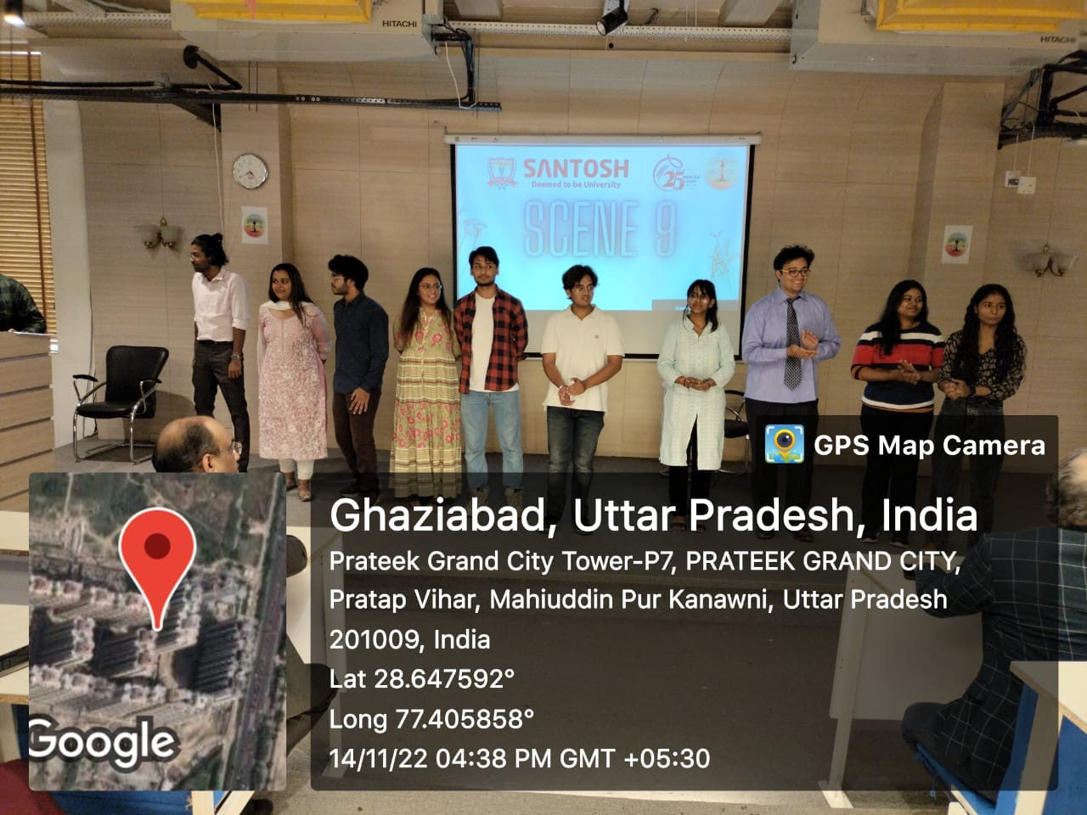

**Appreciation and Conclusion**:

The event concluded with heartfelt appreciation for the participants and gratitude extended to the dignitaries for their presence. MANCHTANTRA's journey begins, promising a platform for artistic expression and collaborative creativity at Santosh Deemed To Be University.

**Participants**:

- Dr. Akanksha Prakash (2018-19)

- Dr. Nikhil Bawara (2018-19)

- Sia Saxena (2020-21)

- Prithu Sharma (2020-21)

- Prateek (2020-21)

- Anushka Kaushik (2020-21)

- Suhani Aggarwal (2021-22)

- Gauransh Bhardwaj (2021-22)

- Sarah Kansal (2021-22)

- Kalash Gupta (2021-22)

- Harshvardhan Raghav (2021-22)

- Mohd. Rahim Siddiqui (2021-22)

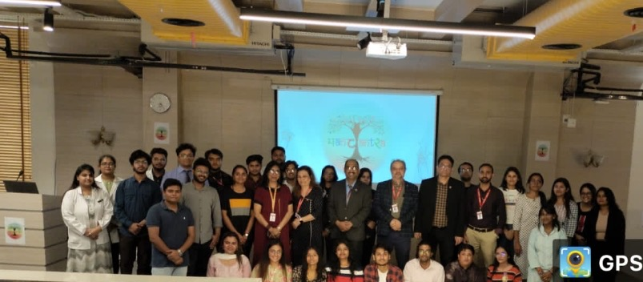The curtain rises on MANCHTANTRA, promising a creative journey of exploration and expression for Santosh Deemed To Be University.

