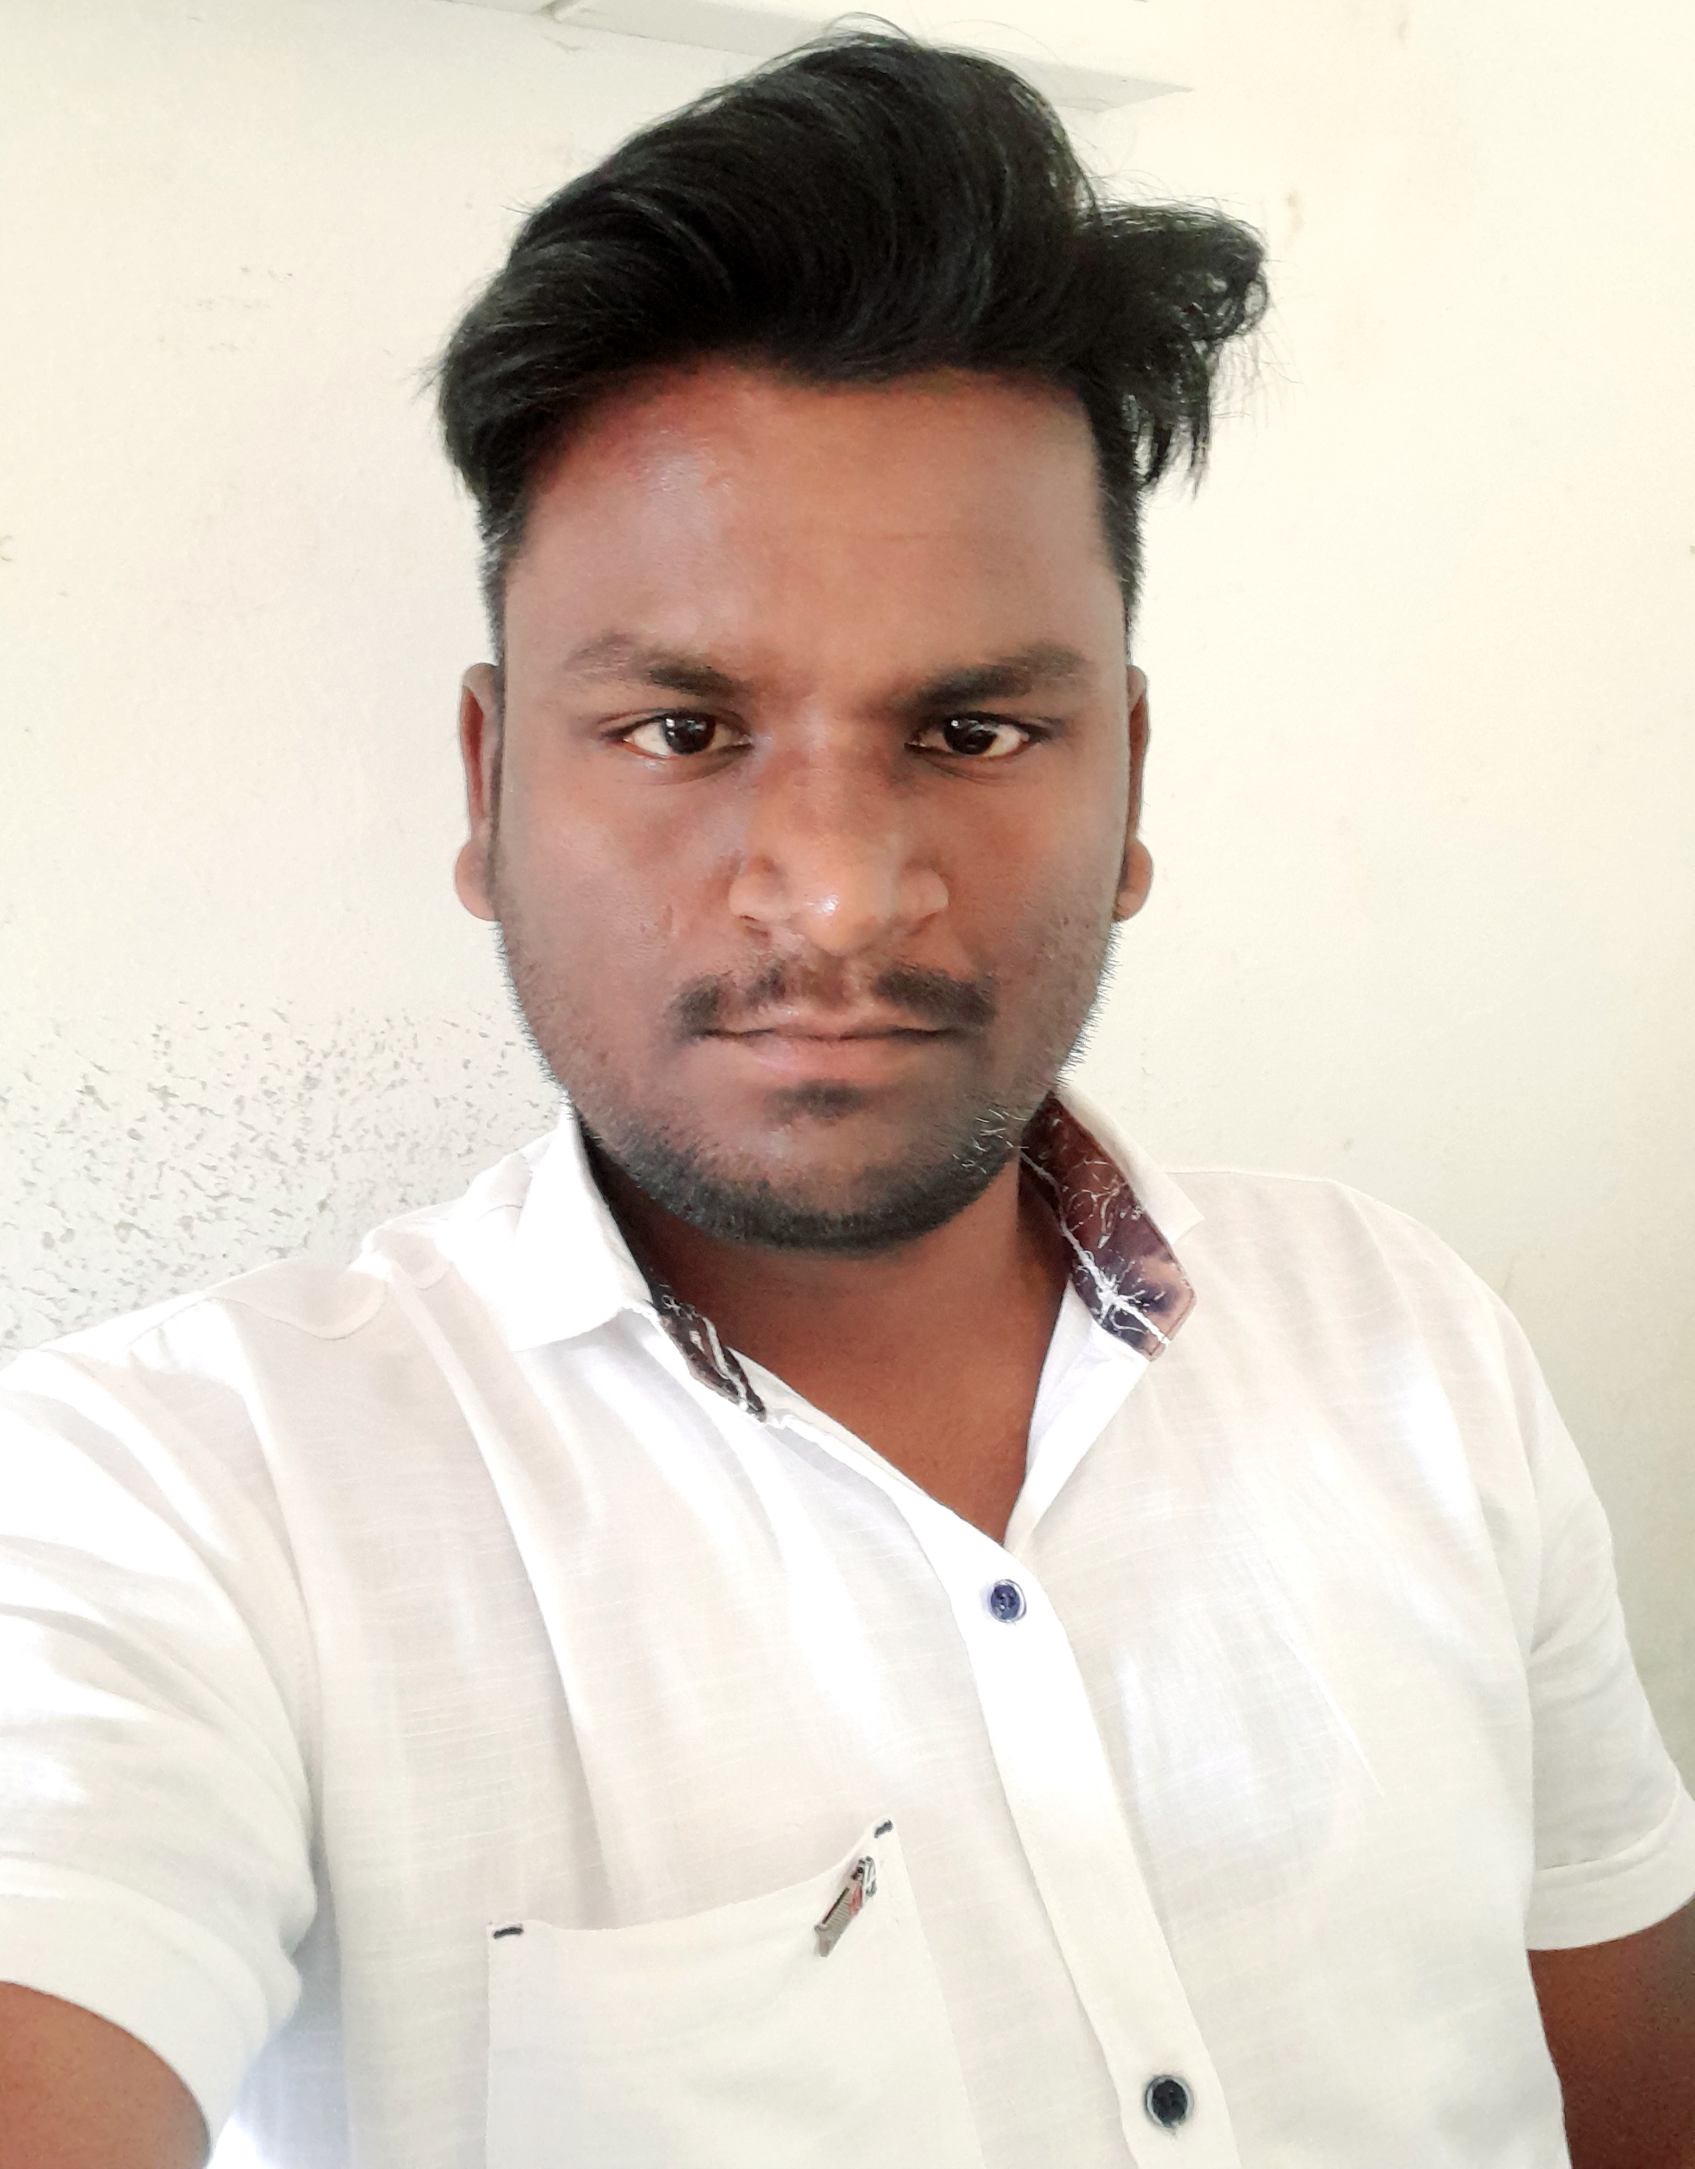

**Ajay Sathe.**

1104,Matoshree House

Sadavali Post, Ratnagiri, Maharastra ,INDIA, PIN 415804

Phone:+91 7977552775

E-mail ajaysathe202@gmail.com

**Operating Theatre Technician.**

31 Years old

**PERSONAL INFORMATION**

Full Name Ajay Anil Sathe

Gender Male

Father’s Name Anil Sathe

Mother’s Name Prabhavati Sathe

Marital Status Single

Religion Hinduism

Born 20/02/1997

Phone +91 7977552775

E-Mail [ajaysathe202@gmail.com](mailto:ajaysathe202@gmail.com)

Passport Number V2982167

Date of Issue 30/09/2021

Date of Expiry 29/09/2031

31 Years o

**EDUCATION**

**2012-2013** S.S.C Passed, 70.80 % marks with st class

**School** S.S.M.V.Kosumb Secondary School,Pune.

**2013-2015** Plus Two passed, 44.92 % marks .

**School**  K.S.M.T.V.S. Higher Secondary School,Pune.

**2015-2016** 1st Year O.T.Technician Semester,Passed with 2ndclas(54.48%)

**2015-2016** 2nd Year O.T.Technician Semester Passed with 2 nd class (58.92%)

**2016-2017**  Final Semester Passed with 2nd class (58.50 %)

**Name of the institution** Maharastra State Board Of Technical Education,

College Of Advanced Studies, Post

Sawarde,Chiplun,Ratnagiri,

Mumbai-Goa Highway

Maharastra,INDIA

**LANGUAGES**

**English :** Fluent, in speaking and in writing

**Hindi :** Excellent

**Marathi** : Native language

**WORK EXPERIENCE**

* 13 months experience from B.K.L.Walawalkar 500 Hundred Bedded Hospital as Jr.Operation Theatre Technician (Orthopeadic and General Surgery OT) [June 4th 2017 – Jully 13th 2018 ]
*  Superspaciality DR.L.H.Hiranandani Hospital 240 Bedded, Specialize in Ortho Pedic and Trauma And General Surgeries All Cases .[March 1st August 2018 - 4th May 20169]
*  Bai Ratan Bai Gharda Hospital, (From11th Dec 2019
* Currently Present Here Bai Ratan Bai Gharda Hospital.

**HOSPITAL INVOLVED TRAINING**

* Trained in Spinal,Epidural,General Anesthesia To assist Anesthesiologist,Assist Positioning Lithotomy,Prone,Lateral,Orthopedic Surgeries How To Give Positions procedures in **B.K.L.Walawalkar Hospital.**
* Sawarde,Chiplun,Maharastrsa for 1 Year.2016 During My Diploma Persuing Time.

**Operation Theatre Technician Responsibilitys.**

* Receiving the patients from Preoperative
* Prepare Anesthesia Needed Drugs and equipments.
* Vitals signs monitoring
* Transferring of patients to OT table
* Assist Insertion of IV cannula
* Assisting in central line insertion
* Assisting in combined spinal and epidural procedure
* Assisting in lumbar puncture
* Assisting for intubation
* Assisting for extubation
* E T and oral suctioning
* Assisted for defibrillation
* CSSD sterile techiniques
* Opening prosthesis in sterile manner
* Transferring of patients
* Management of patient during recovery period
* Continuous cardiac monitoring and pulse oxymeter monitoring
* Suturing of surgical wound
* Femoral block Assisting
* Work as part of a team to provide pain management interventions and injections
* Maintenance and handling of O.T. Equipments.
* Knowledge of all general surgeries, Orthopedic surgeries, Gyneac surgeries, Opthal surgeries, plastic surgeries.
* Assisting Anesthesia side as well as surgery side.
* Knowledge of all O. T. techniques and anesthesia techniques.
* Operating C-arm, X-ray Machine.
* Knowledge ff all Laproscopic and Indoscopic Surgeries.
* Handling Microscope / Lap System,Harmonic Quatery .

**CASES HANDLING: SCRUB AND CIRCULATING**

**Orthopedics surgery**

TKR

IM Nailing

ORIF

JESS fixation

POP application

ACL and PCL repair

THR

DHS

Wound debridement

Implant removal

Micro discectomy

External fixators

Bipolar

External fixation

**General Surgeries including Laparoscopic Surgeries**

Thyroidectomy

Appendectomy and LAP. Appendectomy

Breast biopsy

Cholecystectomy and LAP. Cholecystectomy

**EXTRA CURRICULAR ACTIVITIES**

* Participate in inter college culturel and sports activities .

**DECLARATION**

I hereby declare that the above-mentioned information is correct up to my knowledge and I bear the responsibility for the correctness of the above-mentioned particulars.

AJAY ANIL SATHE.